Facebook 2018
Facebook in 2017 and 2018 has had a rather challenging year. First the revelation of the abuse of its platform and interference with the American presidential election and then the scandal with the data abuse of Cambridge Analytica. Both issues has caused a rapid drop in the use on the number of the Monthly Active Users (MAU), which in many ways is the major element of stock pricing for social networks. Let s try to estimate a “fair” value for Facebook in March 2018, during a period, when both issues are at their peak. Is Facebook fairly priced, or is the bad media a hype?
The annual report for 2017 (most up-to-date) can be found here:
https://investor.fb.com/financials/?section=annualreports

Statistics about Monthly Active users is taken from:
- https://zephoria.com/top-15-valuable-facebook-statistics/
- https://www.thesocialmediahat.com/active-users
- https://www.statista.com/statistics/272014/global-social-networks-ranked-by-number-of-users/
Item | Value
Monthly Active Users (MAU) | 2.13b
MAU (yoy) growth | 14%
Debt (mostly consists of capitalized leases) (m) | $6,417
Equity (BV) (m) | $74,347
Market price 3m avg | ≈$170
Equity (MV)=#shares x MP (page 61) (m) | $ 2,906 x 170 ≈ $494,020
M/B | ≈6.64
Debt Ratio (in 2016 the book value is 4.66%). I assume that debt ratio is stable at around 4% (consistent with Damodaran). | 4.09% (Damodaran) or 7.9% (book Value) or 1.2% (Market Value). EIKON provides a long term forecast of 3.6%.
Net Income (m) | $15,934
Cap Ex (m) | $,6,733
Tax (effective) | 2,273/18,207=12.5%
Depreciation (m) | $3,025
NCE/Sales | (6,733-3,025)/40,653=9.1% or 8.32% (Damodaran)
ΔNWC (% of ΔSales) | 4% (EIKON) and 9.95% (Damodaran)
Market Risk Premium | 5.08%
10y US bond yield | 2.75% (current) 3% (long term estimate due to trade war).
Beta ($\frac{D}{D+E}=0.04→\frac{D}{E}=0.0416)$ | 1.18 (annual, Nasdaq), 0.81 (monthly, EIKON)  1.09 (unlevered, Damodaran), ($1.09*(1+\left(1-0.125\right)0.0416=1.13$)

One of the most crucial assumptions that we need to make refers to Sales and especially growth. Fundamental Growth should be expected to be:
$$g_{NI}=ERR x ROE=\frac{\left(1-δ\right)Total Investments}{NI}x\frac{NI}{{BV}_{E}}=\frac{\left(1-0.04\right)\left[0.04x\left(40,653-27,638\right)+0.091*40,653\right]}{15,934}x\frac{15,934}{74,347}=5.45\%$$
Even if there is a drop in the #MAU, where are they supposed to go? Most of the alternatives are owned by FB too…..
https://www.theguardian.com/technology/2018/mar/31/youve-decided-to-delete-facebook-but-what-will-you-replace-it-with
Consequently, growth might not be affected that much. Average growth of earnings and sales
 | Current | Past
Sales | 40,653 | 27,638 | 17,928 | 12,466 | 7,872 | 5,089 | 3,711 | 1,974 | 777 | 272
g_{Sales} | 0.47 | 0.54 | 0.44 | 0.58 | 0.55 | 0.37 | 0.88 | 1.54 | 1.86
Avg | All | 0.80 | 5y | 0.52
NI | 15,934 | 10,217 | 3,688 | 2,940 | 1,500 | 53 | 1,000 | 606 | 229 | -56
g_{NI} | 0.56 | 1.77 | 0.25 | 0.96 | 27.30 | -0.95 | 0.65 | 1.65 | -5.09
 | All | 3.01 | 5y | 6.17
NPM | 0.39 | 0.37 | 0.21 | 0.24 | 0.19 | 0.01 | 0.27 | 0.31 | 0.29 | -0.21
 | All | 0.21 | 5y | 0.28

Analysts’ forecasts:
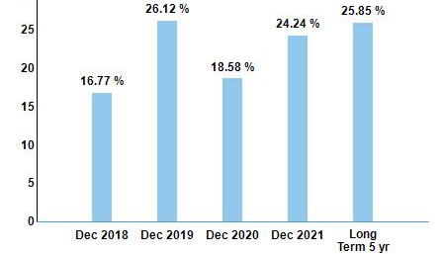
We will make the following assumptions (explicitly). The revenue of Facebook will continue increasing (mainly due to Instagram and WhatsApp), but we also assume that they will offer (as they actually do) a revised data protection policy and therefore they will come back to higher growth from 2019-2020. This is also due to the fact that the majority of MAU is older than 25 years old (which is a slower pace age group) and that the portfolio of investments has widen considerably over the last years.
We assume the following: Growth of MAU will be 0 in the following year, but it will continue to be high (about 10%) for the following 4 years (up to year 5). Then it will start decreasing 2% up until it will reach a long term stable growth of 1%. We also assume that the Revenue/MAU ($40,653/2,130≈$$19) will remain stable and growth will be driven by the #MAU. On the long term (stable growth phase) growth in NI will reach fundamental growth of 5%. In addition, we will assume that although the Net Profit Margin (NPM), which has improved lately (39%), could not be very far from the industry average (13.8%) or the long term average of Facebook (21%). We assume that it will stay at 39% for the next 5 years and then it will gradually decrease (3% a year) till it will reach the long term average of Facebook at 21%. In brief:
 | 0 | 1 | 2 | 3 | 4 | 5
(%) g_{MAU} |  | 0 | 10 | 10 | 10 | 10
(%) NPM |  |  | 39 | 39 | 39 | 39
 | 6 | 7 | 8 | 9 | 10 | 11
(%) g_{MAU} | 8 | 6 | 4 | 2 | 1 | 1
(%) NPM | 36 | 33 | 30 | 27 | 24 | 21

Since the beta of Facebook is close to one (we will use the levered beta of 1.13) we will assume for simplicity a stable cost of equity of:
$$k_{e}=r_{f}+β_{l, FB} x MRP=3+1.13 x 5.08=8.74\%$$
Therefore, the cash flows and the valuation is the following:
 | 0 | 1 | 2 | 3 | 4 | 5
(%) g_{MAU} |  | 0 | 10 | 10 | 10 | 10
MAU | 2,130 | 2,130 | 2,343 | 2,577 | 2,835 | 3,119
Rev/MAU | 19 | 19 | 19 | 19 | 19 | 19
Revenue |  | 40,470 | 44,517 | 48,969 | 53,866 | 59,252
(%) NPM |  | 39 | 39 | 39 | 39 | 39
NI |  | 15783.3 | 17361.63 | 19097.793 | 21007.572 | 23108.3295
NCE=9.1% x Rev |  | 193.83 | 213.21 | 234.53 | 257.99 | 283.79
ΔNWC=4% x Δrev |  | - | 9 | 9 | 10 | 11
δ |  | 4% | 4% | 4% | 4% | 4%
FCFE |  | 15,597.22 | 17,148.77 | 18,863.64 | 20,750.01 | 22,825.01
Discount Factor at 8.74% |  | 0.9196 | 0.8457 | 0.7777 | 0.7152 | 0.6577
Discounted FCFE |  | 14,343.59 | 14,502.88 | 14,670.93 | 14,840.92 | 15,012.89
 | 6 | 7 | 8 | 9 | 10 | 11
(%) g_{MAU} | 8 | 6 | 4 | 2 | 1 | 1
MAU | 3,368 | 3,570 | 3,713 | 3,787 | 3,825 | 3,863
Rev/MAU | 19 | 19 | 19 | 19 | 19 | 19
Revenue | 63,992 | 67,832 | 70,545 | 71,956 | 72,676 | 73,402
(%) NPM | 36 | 33 | 30 | 27 | 24 | 21
NI | 23037.22698 | 22384.50555 | 21163.53252 | 19428.123 | 17442.137 | 15414.4885
NCE=9.1% x Rev | 306.49 | 324.88 | 337.87 | 344.63 | 348.08 | 351.56
ΔNWC=4% x Δrev | 10 | 8 | 6 | 3 | 2 | 2
δ | 4% | 4% | 4% | 4% | 4% | 4%
FCFE | 22,733.42 | 22,064.86 | 20,833.69 | 19,094.43 | 17,106.53 | 15,075.52
DF | 0.6049 | 0.5563 | 0.5115 | 0.4704 | 0.4326
DF (FCFE) | 13,750.82 | 12,273.71 | 10,657.41 | 8,982.61 | 7,400.63 | 174,384.35
MCAP | 300,820.75 | or per share | 103.52
The DCF valuation gives us a price of $103.52 per share. This implies that the stock is significantly overvalued.
Multiples valuation
The valuation above is based on our assumptions derived from various sources. Let us try to estimate the value of Facebook based on market expectations. We will focus on market-wide expectations (S&P500) as well as on close competitors (derived from EIKON). Their multiples can be summarized in the table below:
Company Name | Price / EPS | Price / FCFE | Market / Book | Price / Sales | Dividend Yield %
Facebook Inc | 20.30 | 15.88 | 4.56 | 7.64
Twitter Inc | 41.15 | 22.99 | 3.83 | 7.75
Microsoft Corp | 23.33 | 15.28 | 6.78 | 6.10 | 1.9%
Tencent Holdings Ltd | 34.57 | 22.91 | 8.57 | 8.35 | 0.3%
Alphabet Inc | 23.67 | 16.75 | 4.01 | 5.09
Amazon.com Inc | 135.00 | 23.96 | 17.19 | 2.80

We will use the P/E ratio as the most consistent valuation, as well as, we will construct our own multiple Price/MAU computed as MCAP/#MAUs
Company Name | MCAP  (3m in $b) | MAU  (in #b) | Price / MAU
Facebook Inc | 494.02 | 2.13 | 231.93
Twitter Inc | 21.78 | 0.33 | 66
Microsoft Corp | 702.76 | - | -
Tencent Holdings Ltd*  (QQ, WeChat,QZone) | 495.64 | 2.39 | 207.38
Alphabet Inc*  (Youtube) | 718.87 | 1.5 | 472.58
Amazon.com Inc | 700.67 | - | -

The estimates with * would probably mis-price the asset because the holding company has a much wider portfolio of investments. In general, Facebook is the leading social network, so using other social networks as a reference, would mis-price the asset. Therefore, we will focus on a more traditional multiple valuation approach, using the P/E and P/Sales ratios.
Based on peers:
$$\frac{P_{low}}{E_{low}}≤\frac{P_{FB}}{E_{FB}}≤\frac{P_{high}}{E_{high}}$$
$$\frac{P_{FB}}{E_{FB}}≤41.15→P_{FB}≤41.15 x E_{FB}=41.15 x 15,934=\$655,684m or \$225.63 per share$$
Twitter was chosen as the best performing social network. In addition, based on the average (40.82 with Amazon and 25.12 without)
$$\frac{P_{low}}{E_{low}}≤\frac{P_{FB}}{E_{FB}}≤\frac{P_{high}}{E_{high}}→25.12≤\frac{P_{FB}}{E_{FB}}≤40.82→25.12x 15,934≤P_{FB}≤40.82 x 15,934$$
$$\$400,262m or \$137.74 per share≤P_{FB}≤\$650,425m or \$223.81 per share$$
We can also use the P/Sales Ratio
$$\frac{P_{low}}{{Rev}_{low}}≤\frac{P_{FB}}{{Rev}_{FB}}≤\frac{P_{high}}{{Rev}_{high}}$$
$$2.8≤\frac{P_{FB}}{{Rev}_{FB}}≤8.35→2.8 x 40,653≤P_{FB}≤8.35 x 40,653=$$
$$\$113,828m or \$39.17 per share≤P_{FB}≤\$339,452.55m or 116.81 per share$$
Based on the average (5.63)
$$\frac{P_{FB}}{{Rev}_{FB}}≈5.63→P_{FB}≈5.63 x 40,653≈\$228,876.39m or \$78.76 per share$$
Most of the valuations indicate that Facebook is already over-valued, even after the recent sharp drop.

Based on peers:
However, we need to acknowledge that the small peer group is not ideal and might not even be comparable. We will still use the P/E and P/Sales multiples, but we will compare FB to the market as a whole, based on the fundamentals that drive the two multiples:
Regression
PE = 4.20 + 149.0 g_{EPS} + 13.40 Payout - 2.86 Beta
(3.35) (26.82) (18.50) (2.93)
PS= 0.31+0.04 Payout + 9.17 g_{EPS} - 0.47 Beta + 12.60 Net Margin
(2.88) (4.70) (19.58) (4.54) (37.00)

Consequently, for FB
Regression | Multiple | Item | Price
PE  = 4.20 + 149.0 x 0.2 + 13.40 x 0 - 2.86 x 1.13 | 30.76 | Earnings  $15,934m | $490,129.84m  Or $168.66 p.s.
PS  = 0.31+0.04 x 0 + 9.17 x 0.2 - 0.47 x 1.13 + 12.60 x 0.39 | 6.53 | $40,653m | $265,464.09m  Or $91.35 p.s.

Overall, the P/E multiple is a more consistent valuation than the P/S because the second is affected by the capital structure (FB is an extreme case with very low debt ratio and therefore, it would be generally undervalued) and therefore generates biased results. It would be better to be used only in non-profitable firms. The P/E valuation here provides wide, but very consistent results with the MCAP at the moment. Therefore, the asset, according to market expectations, seems to be rather “fairly” priced. However, this valuations cannot be supported by our DCF assumptions. In order to check the validity of our DCF assumptions it would be worth to compute the implied rates that would make the valuation equal to the current MCAP ($464.19b).
First we can check the cost of equity. A rate of 8.74% would yield a valuation of $300,820.75m and a difference of $300,820.75m-$464,190m=-$163,369.25m. A valuation with 7% discount rate would yield a valuation of $520,335.89m and a difference of $520,335.89m -$464,190m=$56,145.89m. The implied cost of equity is:
$$k_{e_{implied}}={DR}_{low}+\frac{{NPV}_{low}}{{NPV}_{low}-{NPV}_{high}}\left({DR}_{high}-{DR}_{low}\right)=$$
$$7\%+\frac{\$56,145.89m}{\$56,145.89m-\left(-\$163,369.25m\right)}\left(8.74\%-7\%\right)=7.45\%$$

This estimate of the cost of equity is reasonable and could be given by using a slightly lower risk free rate in combination with a lower MRP.

Then we can investigate other inputs, such as:

- The growth of MAU. A different estimate with different expectations.

 | 0 | 1 | 2 | 3 | 4 | 5
(%) g_{MAU} |  | 10 | 14 | 14 | 14 | 14
MAU | 2,130 | 2,343 | 2,671 | 3,045 | 3,471 | 3,957
Rev/MAU | 19 | 19 | 19 | 19 | 19 | 19
Revenue |  | 44,517 | 50,749 | 57,854 | 65,954 | 75,187
(%) NPM |  | 39 | 39 | 39 | 39 | 39
NI |  | 17361.63 | 19792.2582 | 22563.17435 | 25722.01876 | 29323.10138
NCE=9.1% x Rev |  | 213.21 | 243.06 | 277.09 | 315.88 | 360.11
ΔNWC=4% x Δrev |  | 9 | 13 | 15 | 17 | 19
δ |  | 4% | 4% | 4% | 4% | 4%
FCFE |  | 17,148.77 | 19,546.32 | 22,282.81 | 25,402.40 | 28,958.74
Discount Factor at 8.74% |  | 0.9196 | 0.8457 | 0.7777 | 0.7152 | 0.6577
Discounted FCFE |  | 15,770.43 | 16,530.52 | 17,330.13 | 18,168.43 | 19,047.28
 | 6 | 7 | 8 | 9 | 10 | 11
(%) g_{MAU} | 12 | 10 | 8 | 8 | 8 | 8
MAU | 4,432 | 4,875 | 5,265 | 5,687 | 6,141 | 6,633
Rev/MAU | 19 | 19 | 19 | 19 | 19 | 19
Revenue | 84,210 | 92,631 | 100,041 | 108,045 | 116,688 | 126,023
(%) NPM | 36 | 33 | 30 | 27 | 24 | 21
NI | 30315.57558 | 30568.20538 | 30012.41983 | 29172.07207 | 28005.18919 | 26464.90378
NCE=9.1% x Rev | 403.32 | 443.65 | 479.15 | 517.48 | 558.88 | 603.59
ΔNWC=4% x Δrev | 19 | 18 | 16 | 17 | 18 | 20
δ | 4% | 4% | 4% | 4% | 4% | 4%
FCFE | 29,910.15 | 30,125.28 | 29,537.46 | 28,659.12 | 27,451.20 | 25,866.60
 | 0.6049 | 0.5563 | 0.5115 | 0.4704 | 0.4326
 | 18,091.84 | 16,757.37 | 15,109.79 | 13,482.14 | 11,875.94 | 299,208.81
MCAP | 461,372.68 | or per share | 158.77

Item | Used | Implied
Long term growth | 5% | 6.81%
NPM (long term) | 39% → 21% | ≈39%
It seems that all our assumptions were consistent with the market, apart from the NPM.
2019 comment: Judging retrospectively, our valuation was towards the right direction. Do not be afraid to defend your valuation if you believe in your assumptions.
September 2025 valuation:
FB has made a very big investment in hiring the best talent in AI. Accordingly, we should expect a considerably higher growth in EPS and consequently in Cash Flows. We should wonder, where will this growth come from? From MAU? From an increased portfolio of activities? From new ventures? From things we cannot anticipate? Most likely the last one.
How should we structure our valuation then? My thoughts.
I believe that growth in FB will be primarily reflected in a dominant position in applied AI. Eventually, it is very likely that they will be the first to reach general intelligence (GI) or a full scale applied AI. This will give them the edge over competition and they will experience high demand for their products. I see the following channels
- FB and Instagram will be platforms that will analyse users better and they will provide personalized services. Growth will be observed in MAU in a combined platform. Main source of income: Advertising
- The new AI or GI will be used as an input to other services and that will be charged per request. I anticipate this being the biggest source of income and this will not be necessarily reflected in MAU. Instead, I believe that it is more natural to focus on FCFF or FCFE.
- I would anticipate
  - A high growth of around 20% magnitude
  - I believe that advancements will start being visible in 2026-2027
  - Competition in AI is fierce and I do not see this happening for longer than 3 years
  - Then for another 3 years I see transition to 5% growth that will stay at this level due to economies of scale and certain monopolies (not all products)
- With respect to ROE, I see that increasing drastically and staying high in the foreseeable future, but at a level that is sustainable on the longer term
Time | Growth | ROE (Yahoo finance) | ERR
0-1 | 3% | 40% | 50% (assumption)
1-3 | 20% | 40% | 50%
4 | 15% | 35% | 50%
5 | 10% | 30% | 43%
6 | 7.5% | 25% | 33%
6+ | 5% | 20% | 30%
Net income is currently around $71.5b with EPS 28.31. In addition, the tariffs and the macro-challenges might affect significantly borrowing costs. The risk free rate is expected to reach a long term value of 3%
Time | rf | beta | MRP | Ke
0-1 | 4% | 1.24 | 4.33% | 9.37%
1-3 | 5% | 1.3% | 4.5% | 10.85%
4 | 4% | 1.5% | 5% | 11.50%
5 | 3.5% | 1.2% | 5% | 9.50%
6 | 3.5% | 1.1% | 5% | 9.00%
6+ | 3% | 1 (in line with market) | 5% | 8.00%

According to the assumptions above, the price for META could reach the following level
 | NI | G | ERR | FCFE | ke | Discount factor | DCF | 
0 | 28.31 | 0.04 | 50% |  |  | 1
1 | 33.97 | 0.2 | 50% | 16.99 | 9.37% | 0.9143 | 15.53
2 | 40.77 | 0.2 | 50% | 20.38 | 10.85% | 0.8248 | 16.81
3 | 48.92 | 0.2 | 50% | 24.46 | 10.85% | 0.7441 | 18.20
4 | 56.26 | 0.15 | 43% | 32.07 | 11.50% | 0.6674 | 21.40
5 | 61.88 | 0.1 | 33% | 41.46 | 9.50% | 0.6095 | 25.27
6 | 66.52 | 0.075 | 30% | 46.57 | 9.00% | 0.5591 | 26.04
6+ | 69.85 | 0.05 | 25% | 52.39 | 8.00% | 0.5591 | 976.40
 |  |  |  |  |  | Price/share | 1099.65
This is clearly a very strong buy, since the current market price is around $760. Let s see what other analysts believe.
According to technical Analysis, it is a strong buy in all frequencies.
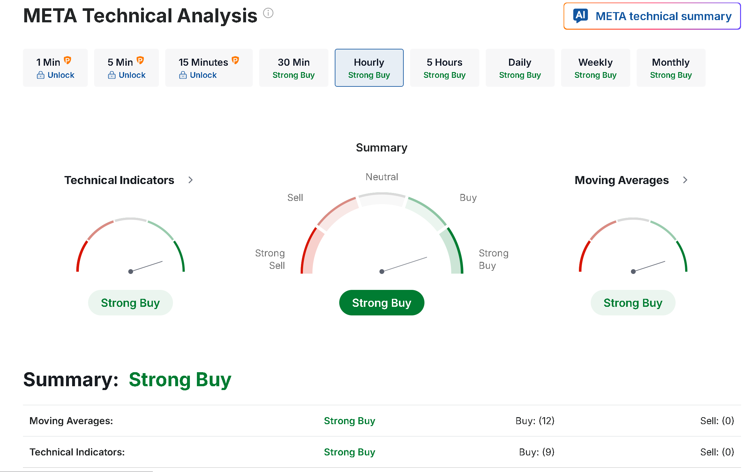
According to fundamental analysis, everybody recommends a buy
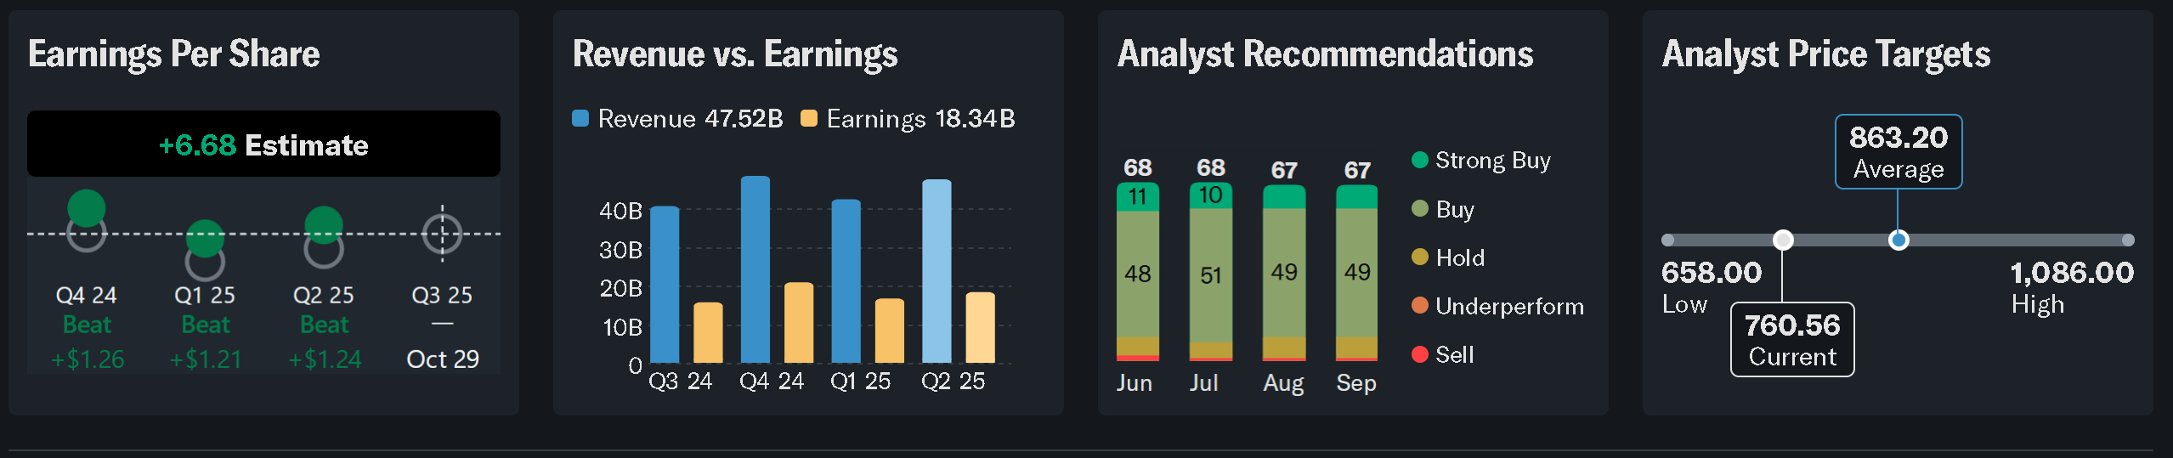
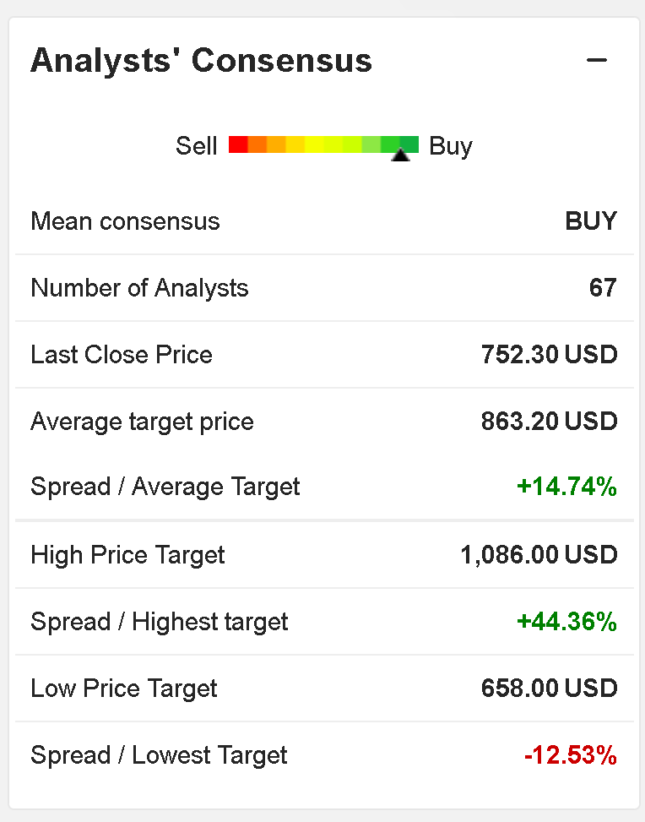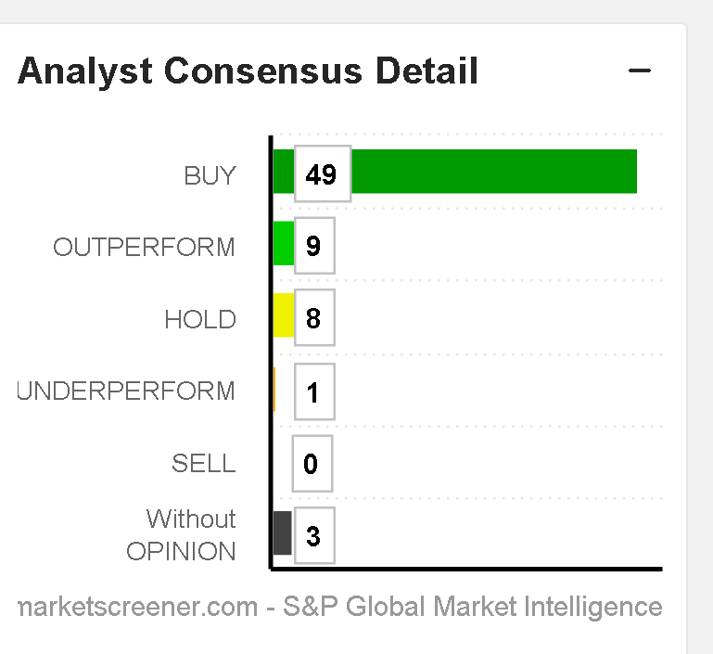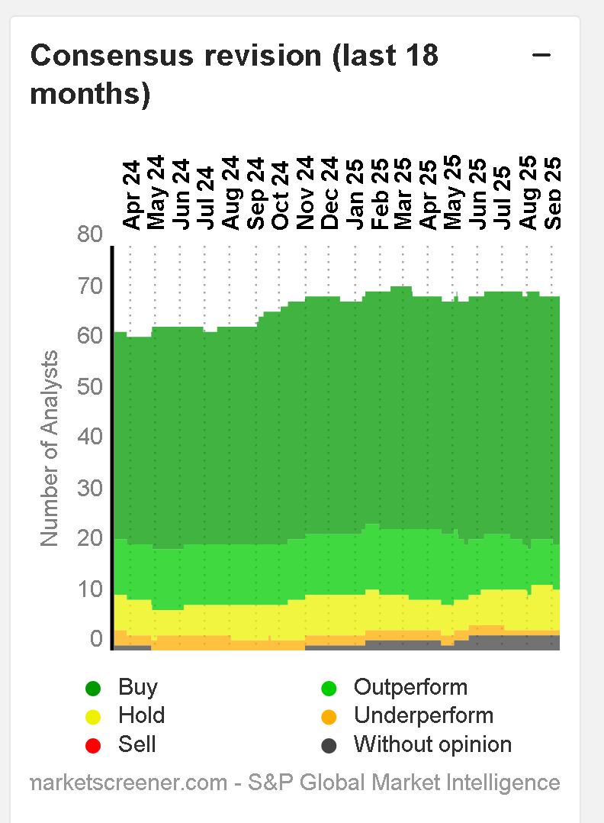
This valuation is September 2025: target price over $1,000
Price in February 2026 around $600
What did go wrong?

